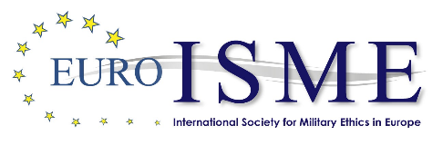

Registration Form
Euro-ISME 2023 Annual Conference

The Future of Military Ethics

Hellenic Air Force Academy, Athens, Greece 10-12 May 2023

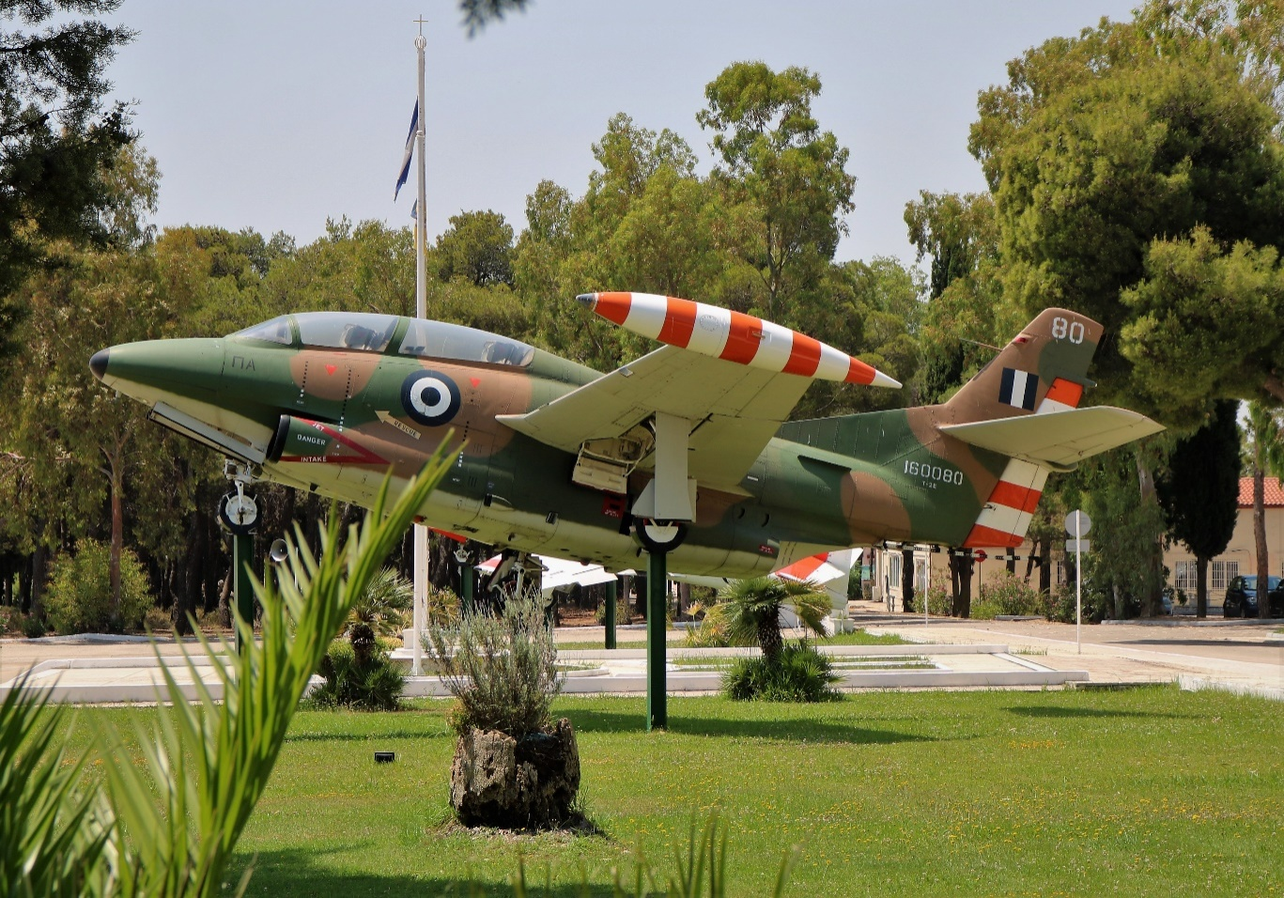

Conference Registration
The deadline for registration is 12 April 2023

All participants must complete a registration form. The submission of a paper for consideration and/or its acceptance is not sufficient for registration.

Family name:

Rank / academic title:

First name:

Organization / institution:
Professional address:

Telephone(s) (please include country code):
Landline: Mobile:
E-mail:
Passport number:
Expiry date:
Nationality:

Conference Dinner

Due to unforeseen circumstances not under the control of Euro-ISME, we have been unable to finalise the venue for the conference dinner.
We will notify all participants of the venue as soon as it is known.
I would like to attend the conference dinner on Thursday 11 May Yes/No
I would like to bring a guest* to the conference dinner. Yes/No
*The cost for each person attending the conference dinner is€ 90
All guest meals should be reserved when registering for the conference.

Dietary requirements
If you have a dietary requirement, please provide specific details here. For example, if you are vegetarian, please let us know whether you eat fish and/or dairy.
If you are bringing a guest to the conference dinner or welcome reception, please remember to also specify their dietary requirements.

If you are bringing a guest to dinner, please provide their details here:

Title: ............................. First name......................................Family name..............................

Conference fees - what is included and what is optional:

Included

Attendance at all conference sessions and panel discussions
Lunches and light refreshments during the conference
Shuttle bus transport from the vicinity of recommended hotels. (See Practical Information page – Hotels)

Optional

The Meet and Greet reception on Tuesday 9 May (25 € per person).
The conference dinner on Thursday 11 May (90€ per person)
Members:

Conference only €250
Additional cost per person for meet and greet €25
Additional cost per person for conference dinner €90

Non Members

Conference only €275
Additional cost per person for meet and greet €25
Additional cost per person for conference dinner €90

Graduate and Undergraduate Students (Student ID Required)

Conference only €220
Additional cost per person for meet and greet €25
Additional cost per person for conference dinner €90

We hope that you will renew your membership or join as a new member. Only members are eligible to vote at the AGM and to stand for election to the Board of Euro-ISME. A membership application form is at the end of this registration form.

If you are an existing member and wish to renew, please do not forget to pay your annual subscription.It is a great help to our volunteer treasurer if membership fees are made as a separate payment from conference fees.

If you live inside the Eurozone, please pay your conference and/or membership fees by direct transfer (SEPA) to the following bank account:

Name: Euro-ISME Association
Bank: Societé Générale
IBAN: FR76 3000 3017 2000 0372 6072 203
BIC/SWIFT: SOGEFRPP

Reference for your payment should be ‘Your family name-ATH23’ ….

If you live outside the Eurozone, please pay using PayPal. You will need to enter the email address of our treasurer: mrevue.treasurer@euroisme.eu

Just go to https://www.paypal.com/re/webapps/mpp/send-money-online and follow the instructions.

You will then be able to pay from your PayPal account, by bank transfer or by credit card.

You do not need a PayPay account to use this method of payment.

These payment methods allow us to minimise bank charges and to keep our conference fee as low as possible.

Please indicate below whether you have paid by

Bank Transfer or PayPal

Please send your completed form by email to arrive before 14 April 2023 to:
Ms Ivana Gošić at : admin@euroisme.eu

Data protection
By submitting your registration form you agree that your data are stored electronically for conference administration and security. You also agree that photographs of your participation can be posted to our website and other social media.

Practical information

Important Note:

The conference location is the Hellenic Air Force Academy (see further details below).
The Academy is in the northern suburbs of Athens, some way distant from the city centre. Please take this into account when planning your travel and accommodation.

The address of the Academy is:

Hellenic Air Force Academy, Dekelia Air Base, PC 13671, Acharnes Attikis, Tatoi.

Hotels

There are relatively few hotels in the immediate vicinity of the Academy and we therefore invite you to consider reserving at one of the 3 hotels listed below (all of which are close to each other). You are of course welcome to book alternative accommodation, in which case we kindly ask you to book your hotel in close proximity to the above recommended hotels.

Euro-ISME is arranging a bus shuttle at the beginning and end of each conference day from a location convenient to these hotels. Please note that these hotels are approximately a 20-minute drive from the Air Force Academy. Details of pick-up points and timings will be included in the information pack which will be sent to all participants about 3 weeks before the conference.

Theoxenia House Hotel(https://theoxeniapalace.com/theoxenia-house/ )
42 Charilaou Trikoupi & 9 Pentelis Street , Kifissia, 145 62 Athens, Greece
The Kefalari Suites(https://www.kefalarisuites.com/ )
Diligianni, 14562 Kifisia
SAY Hotel(https://www.sayhotel.gr/ )
Charilaou Trikoupi, Kifisia, Greece

Further details will be circulated when known.

Please note that private taxis are not permitted to enter the Academy grounds and that the Academy is situated some distance from the main gate.

Travel to Athens

International flights arrive at Athens International Airport.

To reach Kifissia (where the above hotels are situated), the options are:

Taxi The quickest route, about 35-40 minutes. Expect to pay around €50. Several fixed price pre-booked transfer services are available on the internet.

Public transport

Via Metro lines M3 and M1. This journey will take about 1 hour 10 minutes and involve some walking.

Conference Working Language

The main conference language will be English.

Chatham House Rule

The conference will be held under the Chatham House rule. The only exceptions are the ceremonial opening, the key-note speeches, the farewell panel and the prize ceremony at the conference dinner.

The Rule states that:

‘When a meeting, or part thereof, is held under the Chatham House Rule, participants are free to use the information received, but neither the identity nor the affiliation of the speaker(s), nor that of any other participant, may be revealed.’

In addition, no part of the conference may be recorded (sound and/or vision) without the written permission of the presenter and the executive directors.

Visa
Greece is a member of the Schengen Area. Conference participants from outside the Schengen Area who need a formal invitation from EuroISME in order to apply for a visa, are advised to contact Ms. Ivana Gošić as soon as possible.
Given the fact that the application for a visa may take a considerable amount of time, participants are advised to ask for a formal invitation from EuroISME no later than 4 weeks in advance.
Meet and Greet and Conference dinner

The conference dinner and prize ceremony for the Euro-ISME 2022 Ethics Prize will both be heldin the evening of Thursday 11 May.

The venue will be notified as soon as possible. Unforeseen circumstances outside our control have made it impossible to finalise the venue at this time (mid February).

You are most welcome to bring a guest to the conference dinner, but please note that the cost for this will be €90 for each guest, which should be paid at the same time as your conference fee.

The cost for dinner will include a welcome drink, a three-course meal with coffee and wine or soft drinks with the meal.

Information package and joining instructions
Closer to the conference, all registered conference participants will receive an information package plus joining instructions.

EURO-ISME APPLICATION FOR INDIVIDUAL MEMBERSHIP

I (Name) : ………….. (Family Name).........................................
Profession/Title/Rank : ...........................................................
Resident in……………………………..
Profession:……………………
Nationality:…………………………..
Phone:………………………….Fax:………………..
Email:…………………………………………………

Wish to apply for or to renew individual membership of the International Society for Military Ethics in Europe
(Registered in France in accordance with the Law of 1901)

Annual Membership fees

Junior/Student Members (under 25 years or unemployed): €20, 00
Full Individual Membership € 40, 00
For further details see Chapter III / Article 7 of the Euro-ISME statutes at
http://www.euroisme.eu/wp-content/uploads/statutes_euro_isme_final_engl.pdf

Signed at,

Signature........................................,Date.......................………………

                - Please send this application to the secretariat and remit the membership fee to Euro-ISME's bank account (both shown below).

                - A membership certificate will be sent immediately after your accreditation by the Board of Directors

- Euro-ISME
Attn.: Ms Ivana Gošić

E-Mail : admin@euroisme.eu
Web: www.euroisme.eu

Bank Account: Euro-ISME Association : Société Générale, Guer Coëtquidan (01720)
IBAN : FR76 3000 3017 2000 0372 6072 203 BIC : SOGEFRPP

By submitting your application you agree that your data are stored electronically for administration purposes and may be added to our mailing list.

