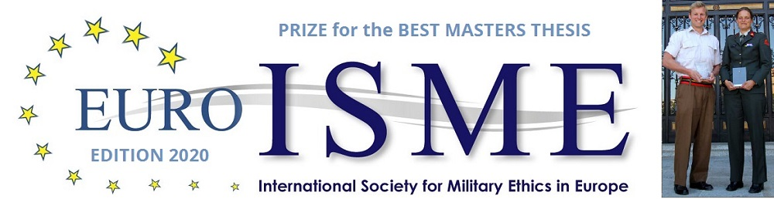
APPLICATION FORM

Personal Information
Name:
Surname:
Date of birth:
Nationality:
Military rank:
Military Branch of Service:
Contact details:
Language Skills:

Academy or University
Name:
Address:
Contact details:

Master Thesis
Title:
Year of Award:
Grade:
Motivation of the supervisor
for this grade:
Name of Supervisor:
Supervisor’s contact details:
Name of Supervisor:
Thesis word count:
Published status of thesis:

Statement of Integrity
The undersigned:
- Has read the statement of scientific integrity;
- Confirms that the submission of the thesis indentified above, is in full conformity with the Statement of Integrity.

Signatures
Candidate:
Date:
Supervisor:
Date:

Please send this form, together with the thesis to Ms. Ivana Gošić at secretariat.ethicsprize@euroisme.eu
If appropriate .
E.g. Army, Navy, Air Force, Marines, Military Police, if applicable.
Not including bibliography.
If the thesis has been published please supply the details so that copyright issues can be addressed.
Described in the Regulations for EuroISMEs Prize for the Best Thesis on Military Ethics.

